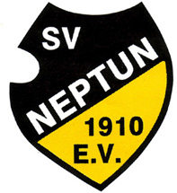
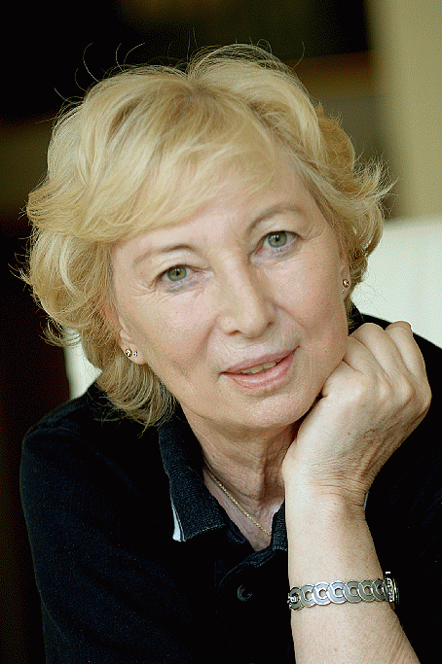
SCHWIMMVEREIN NEPTUN 1910 AACHEN E.V.

Member of simming federation Nordrhein-Westfalen

- Division Diving – DSV national talent development center -

www.aachen-diving.de, www.ulla-klinger-cup.de

8th International Ulla-Klinger-Cup
November 04 – 07, 2021

Federation / Club:
Address:
Phone: | Fax: | e-mail:

 | Participant's name | female | male | born | D / C  B / A | 1m | 3m | Platf. | 3m-Sync. D/C | 3m-Sync. A/B | 3m-Sync.  Mixed  D/C | 3m-Sync.  Mixed  A/B
1
2
3
4
5
6
7
8
9
10
11
12
13
14
15
16

Official / Coach / Judge (max. 6)
1. Judge | 4.
2. Judge (8+) | 5.
3. | 6.

____________________ _______________________________________________
Date Stamp and Signature

Please return this form not later than September 30th, 2021
To: Guido Verse, Püngelerstr. 48, D-52074 Aachen
Fax: +49 (241) 9800146, Email: competition@ulla-klinger-cup.de

